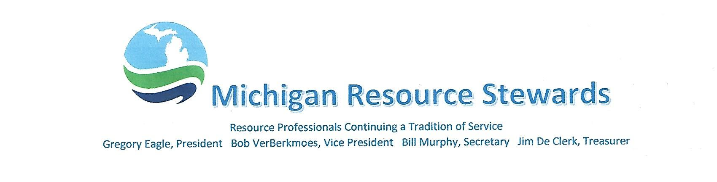

March 24, 2024

Michigan Department of Environment, Great Lakes, and Energy
Executive Office - Attn: Office of EJ Public Advocate
P.O. Box 30473
Lansing, MI 48909-7973
Re: EGLE Policy 09-007 – Public Participation In Department Decisions
The Michigan Resource Stewards (hereafter “Stewards” - www.miresourcestewards.org ) would like to influence the final work product of the EGLE Public Participation Policy and provide the following comments to result in a version that best achieves the goal of access, inclusion and meaningful involvement. The historical policy versions included in the proposed draft may contain such reference information, but the Stewards will take the time to include within their comments the important reports resulting from the Flint Water Crisis. These documents include the report of the Michigan Civil Rights Commission, the Michigan Senate Select Committee, Final Report of the Governor’s Task Force, and the Flint Water Crisis Task Force. Another important report includes the Final Report investigation of Failures of Edenville & Sanford Dams. These references are referred hereafter as “Crisis Reports”. To avoid repeating mistakes of the past, we believe it important that natural resource and environmental crisis investigations must be reflected in documents intended to provide for equitable and meaningful participation in the present. The recent draft policy reflects a lot of EGLE staff effort, thought and consideration. The Stewards thank Director Roos for allowing the public to comment on this draft.
One of the highest concerns of the Stewards has been transparency in government and the ability of each citizen to have influence in government decision-making. In fact, the mission of the Stewards is to advance professional stewardship of Michigan’s natural resources legacy through sound scientific principles, including our land, water, biota and the ecosystems comprising them. This letter will expand on the following topics:
- Constitutional Guidance
- Intent of the Policy & Employee Responsibility/Accountability
- Cultural Change (including corrective justice and legislation improvements)
- Public Advocate Office
- Public Trust Doctrine Clarity
- Petition Process and/or Environmental Commission
- Staff Availability & Approachability
- Overworked Staff
- Staff Ombudsman
First of all, the regulated community has influence far greater than an average citizen or community, especially a disadvantaged community or neighborhood without adequate resources to meaningfully influence EGLE decisions. Also, legislation and administrative rules are heavily influenced by that same regulated community. Nowhere in the Michigan Constitution of 1969 is economic interest provided elevated importance to public health and natural resources preservation concerns. In fact, Article IV, sections 51 and 52, make public health and welfare of “primary” concern and natural resources conservation of “paramount” public concern. Every Michigan public health, environment, or natural resources law or regulation should be analyzed for compliance with and contain reference to this constitutional objective. Though this may not be the reality at this time, the objective of Section IV.51 and Section IV.52 must be observed in the policies of EGLE. The Stewards refer back to Final Report of the Governor’s Task Force and the Civil Service Commission overt referral to these constitutional protections.
Regarding the “ISSUES” section of the draft, this introductory section must state that a meaningful relationship with the Michigan public is a responsibility of every EGLE employee. Also, that trust of the public should be the most important objective of the agency second only to protection of the public and natural resources. That lack of a respectful and approachable relationship between concerned citizens and EGLE (DEQ) employee has been responsible for environmental tragedies and natural resource damages, which the aforementioned crisis reports documented. EGLE should strive to employ staff who are passionate and bear a sworn responsibility to the people they serve or the ecosystem and resources they conserve and protect. Public participation is not just a matter subject to a “framework”, the term as used in the draft, but a conscious state of mind in each staff person and systemic in the department.
The crisis reports seek a systemic change within EGLE. The draft policy needs to overtly state an objective to avoid actions or permitting that contributes to communities suffering disproportionately for decisions purported to equally benefit all, but often benefit the few or are unevenly shared. Often, in our current system, the people who receive the greatest benefit are those that are least exposed to the consequences. The Edenville and Sanford Dam Failures illustrate over $200 million dollars of property damage downstream landowners who had no benefit and little say in management or regulation of the failed dams. The crisis reports point out that, intentionally or unintentionally, EGLE decisions involve a heavily resourced regulated community seeking authorizations while affected communities lack time for environmental involvement, technical/scientific knowledge, professional support, statute and rules expertise, or confidence they can overcome imposing forces. Deadline driven permitting systems put the general public at a disadvantage in meaningful influence by limited time for the general public to adequately prepare to influence agency decisionmakers; while the regulated community has self-determined time to discover and better prepare for citizen expressions of concern. Oftentimes, permit related discussions between regulated parties and agency staff occur long before the general public is noticed of a pending action. Is the establishment of a more supportive “Public Advocate” warranted? We think so. This is illustrated by the aforementioned dam failures where legislation and regulations changes recommended have yet to be proposed by EGLE.
Systemic change must include providing the public with detailed education on regulatory legal-eze, decision-making process, and as stated, “plain language” science. Often permits are focused on point source emissions, but fail to consider cumulative impacts to a community or impacts on community values. Plus, the agency must be candid on factors or evidence that will not be considered due to law and rules provisions so that citizens can target the most influential factors and better understand where they must push for legislative changes and improvements. The Nestle drinking water withdrawal matter illustrates a situation whereby thousands of public comments had little influence on agency decisions due to prescribed permitting requirements and where the agency lacked a clear position on the public trust doctrine. EGLE must identify and encourage changes in law or rules that seek to circumvent or exclude important public participation and public trust factors.
Prior DEQ Director Steven Chester, while leading an Agency Environmental Advisory Council, proposed meaningful changes to address the needs of the less heard citizens via a “petition process” to elevate unheard or misheard concerns beyond normal review processes. The Michigan Civil Service Commission and the Senate Select Committee recommended consideration of an Environmental Quality Commission. In theory, the Michigan Natural Resources Commission provides a venue for any citizen to have opportunity to influence DNR decision-making. The Stewards concede that workable processes or commissions can be flawed in reality, but this should not be a reason to not consider improvements to flawed existing systems.
Public access and influence depend on approachability of agency staff. The pandemic negatively effected the EGLE system through relocation of staff outside of physical office facilities. Landline telephone connection has been replaced by cell phone connectivity. General call centers or email addresses replace location-based offices and the ability to walk in is virtually non-existent. The approachability of agency staff has become a function of the individual staff person rather than an agency posture. Relationships are improved by communities having access to their own local EGLE office and staff resources. Too many tragedies and crises have resulted from disrespectful or unapproachable staff; and taxpayers have had to foot the bill for successful lawsuits for violations of citizen rights.
The draft policy will put additional burdens on agency staff without sufficient support to carry on regular duties in addition to environmental justice matters. The dam failures shed a light on the grossly inadequate funding of the dam safety program and it’s staffing that was only addressed after the tragedy. Staff also bears untenable burdens dealing with the concerned general public without adequate statutory, regulation, or policy resources to address protection concerns. In an overworked environment, it is human to default to one employee’s area of expertise and not be inclined to solve problems outside the box. “It’s not my job,” can arguably be a legitimate position for the over worked. One division may avoid the responsibilities overlapping with another division; or a staff person concerned for a citizen may not have adequate authorization or inclination to work through the bureaucracy of another less familiar program. Multi-media coordinators once served within each district office to serve as hearings officers, a troubleshooter for a concerned citizen, to encourage inter-divisional interaction, and were in a position to detect systemic problems and needed changes. These leadership positions no longer exist. Public advocacy could be a responsibility of a multi-media coordinator. Speaking of staff concerns, the earlier mentioned crisis reports identified the need for an ombudsman position to serve as a resource to employees concerned about inappropriate hierarchy pressures or the lack of empowerment to protect the public.
The Michigan Department of Environment, Great Lakes, and Energy has not yet achieved needed cultural change and this draft policy does not implement changes recommended in many public forums and reports. These historical reports stemming from past mistakes and tragedies must not be wasted efforts destined to sit on dusty shelves. A crises report stated, “Environmental justice or injustice, therefor is not about intent. Rather, it is about process and results—fair treatment, equal protection, and meaningful participation in neutral forums that honor human dignity.” The Stewards suggest slowing the process of finalizing this draft policy so as to result in an improved and system changing document.
Respectfully,
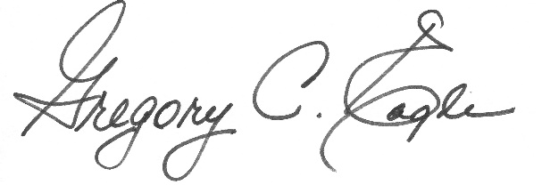
Gregory C. Eagle. President
Michigan Resource Stewards
(989) 513-2508

Cc: EGLE-Engage@Michigan.gov

